Periodic Boundary Conditions (PBCs)

1. Prepare the domain composed of spins as follows: ex) siteSpin: 1D array pointer

Its xdim and ydim can be imported on the command window, and its size can be equivalent and/or different.

à Store sequential numbers to the siteSpin array

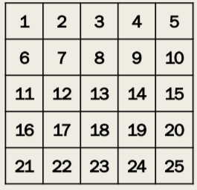

2. Imagine the periodic microstructures as follows: Red = Real, others = Hypothetical

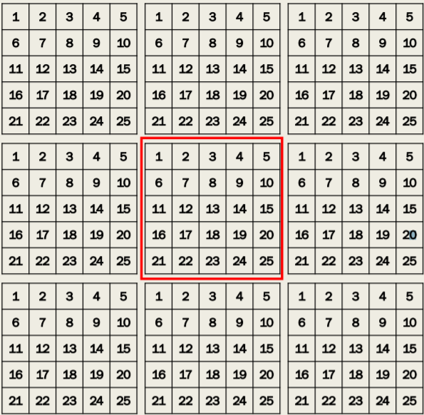

3. Select sites in the domain in regular sequence   
4. Print out the site IDs of neighbors on the command window   
5. repeat step 3 and 4 until the final site is be selected and printed out

\*Notice: Don’t use “if” and “switch” functions Hint: IDs are composed of the hypothetical x and y components. Use +, -, \*, /, %

